**Comcast Telecom Consumer Complaints**

Q1) Import data into R environment

Ans) The code for importing the data into R environment is mention below:

print("Comcast Telecom Consumer Complaints")

com_data<-read.csv("C:/Users/shiva/Desktop/Shivani/SimpliLearn/Data Science with R/Comcast.csv")

print(com_data)

View(com_data)

str(com_data)

summary(com_data)

The output of importing the data in R is attached below:

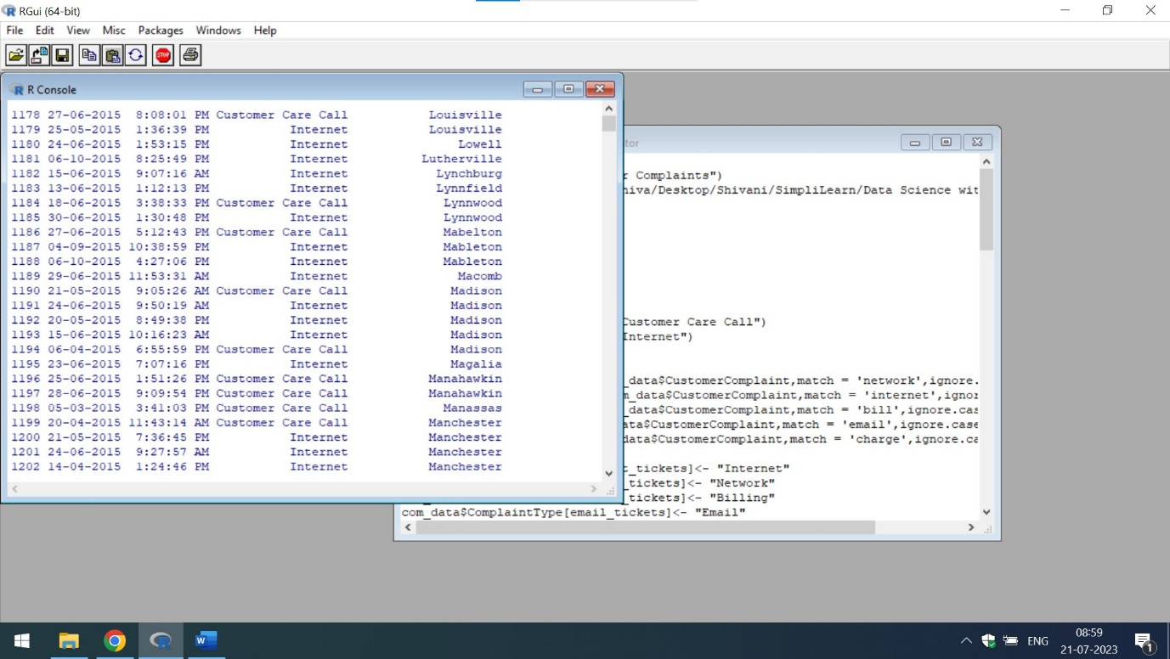

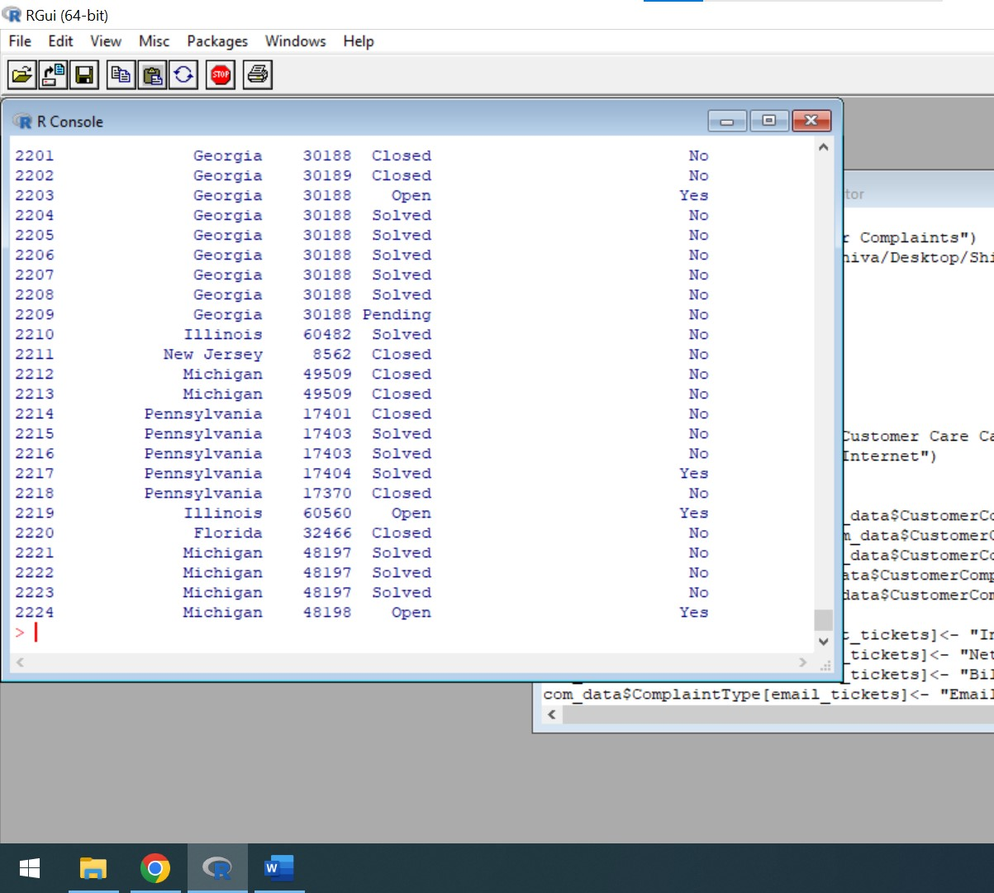

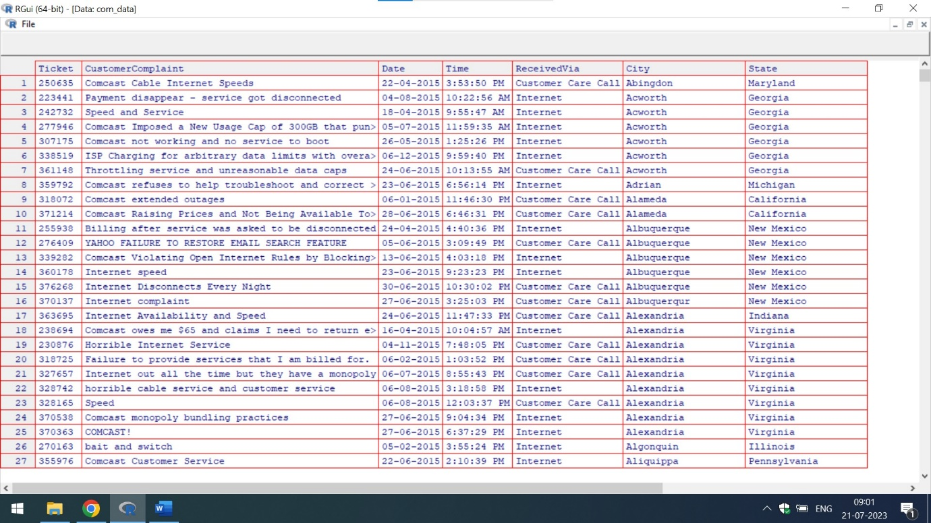

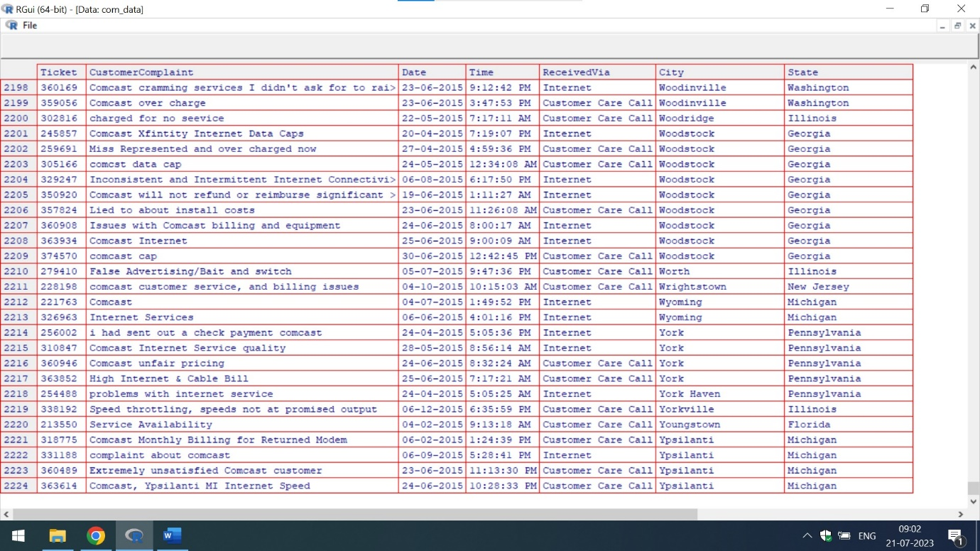

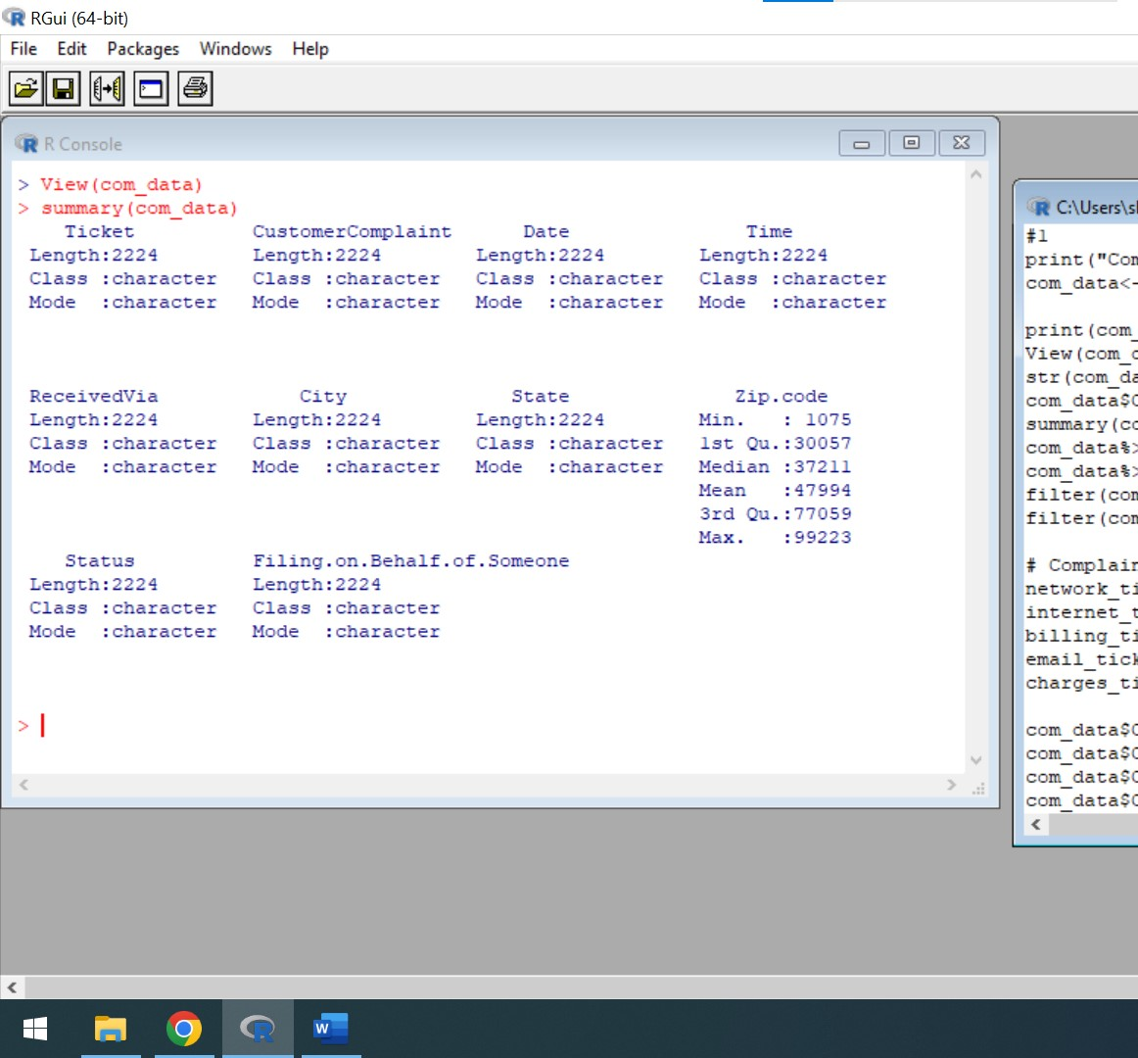

The above mentioned screenshots represents the customer complaints of various cities of States in tabular format

Q2) Provide the trend chart for the number of complaints at monthly and daily granularity levels.

Ans) For trend chart,I am using the concept of Ggplot. In Ggplot, the data column is placed on x-axis and tickets column is placed on y-axis

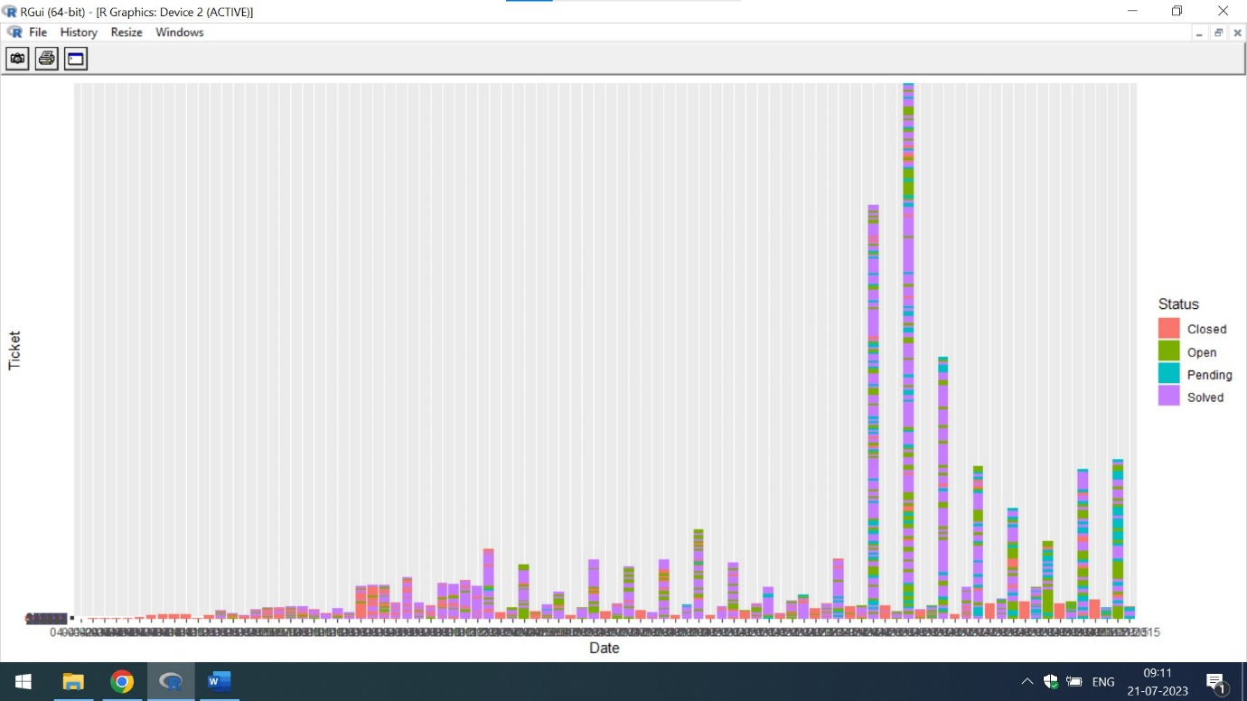

The above mentioned trend chart represents the status of various cases of various tickets.

The screenshot represents that number of solved cases are increasing to a particular point, and then gets decreased

The below mentioned is the line chart view of status of various ticket for various dates

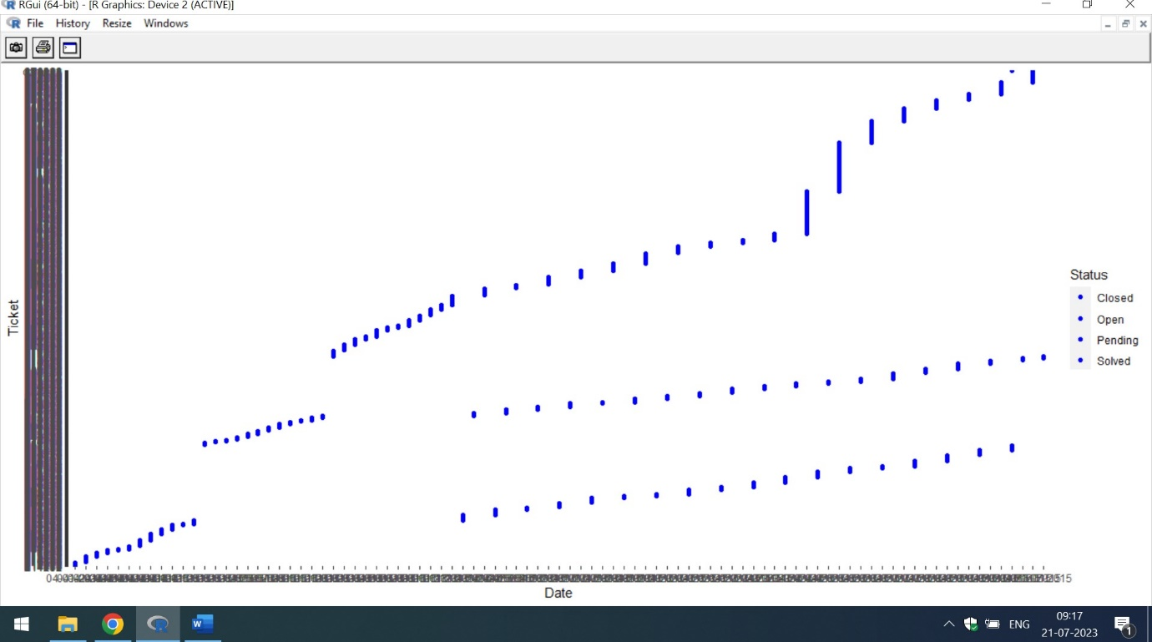

Q3) Provide a table of frequency of complain types

Ans) The code of frequency of complain types is mention below:

print("Comcast Telecom Consumer Complaints")

com_data<-read.csv("C:/Users/shiva/Desktop/Shivani/SimpliLearn/Data Science with R/Comcast.csv")

print(com_data)

View(com_data)

str(com_data)

com_data$CustomerComplaint

summary(com_data)

com_data%>%select(2,5)

com_data%>%select(2)

filter(com_data,ReceivedVia=="Customer Care Call")

filter(com_data,ReceivedVia=="Internet")

# Complaint Type Processing

network_tickets<- contains(com_data$CustomerComplaint,match = 'network',ignore.case = T)

internet_tickets<- contains(com_data$CustomerComplaint,match = 'internet',ignore.case = T)

billing_tickets<- contains(com_data$CustomerComplaint,match = 'bill',ignore.case = T)

email_tickets<- contains(com_data$CustomerComplaint,match = 'email',ignore.case = T)

charges_ticket<- contains(com_data$CustomerComplaint,match = 'charge',ignore.case = T)

com_data$ComplaintType[internet_tickets]<- "Internet"

com_data$ComplaintType[network_tickets]<- "Network"

com_data$ComplaintType[billing_tickets]<- "Billing"

com_data$ComplaintType[email_tickets]<- "Email"

com_data$ComplaintType[charges_ticket]<- "Charges"

com_data$ComplaintType[-c(internet_tickets,network_tickets,

billing_tickets,charges_ticket,email_tickets)]<- "Others"

table(com_data$ComplaintType)

In the above code, I am categorizing the complains in Internet,Network,Billing,Email and Charges Section. The screenshots of the complains received via Internet and CustomerCare call are mentioned below:

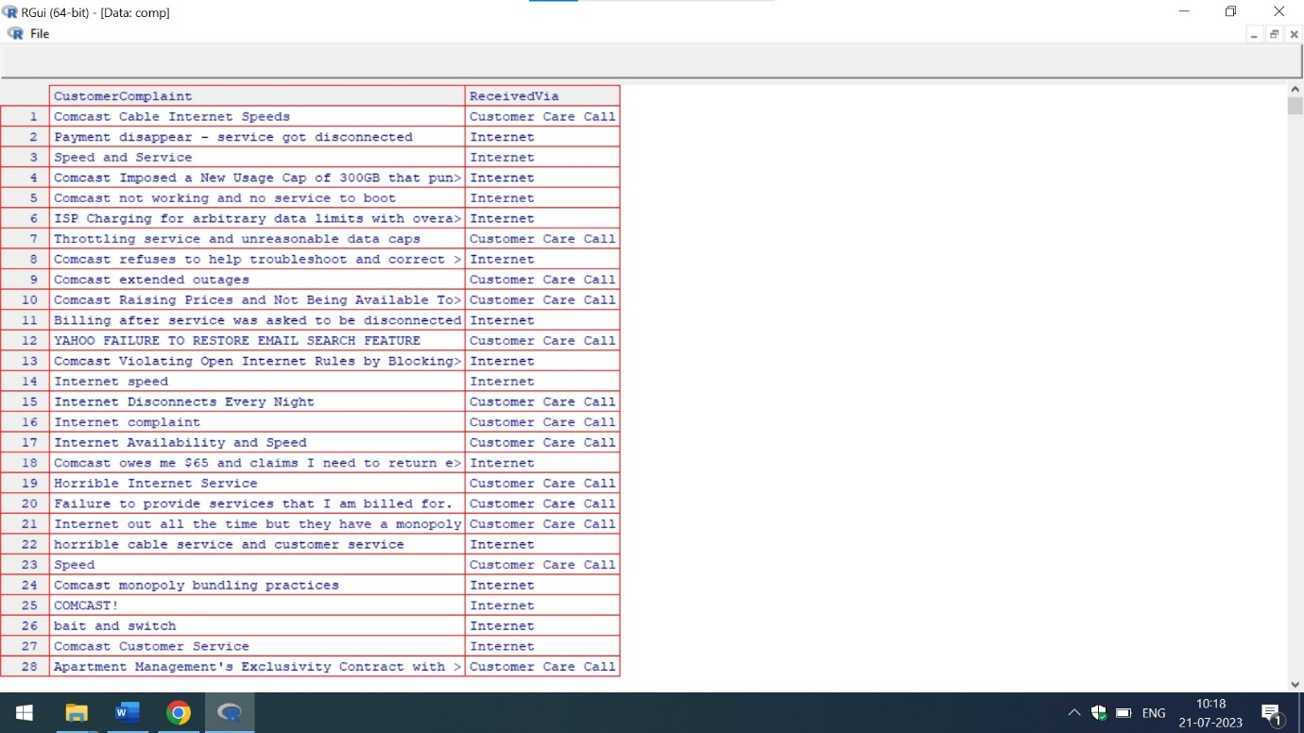

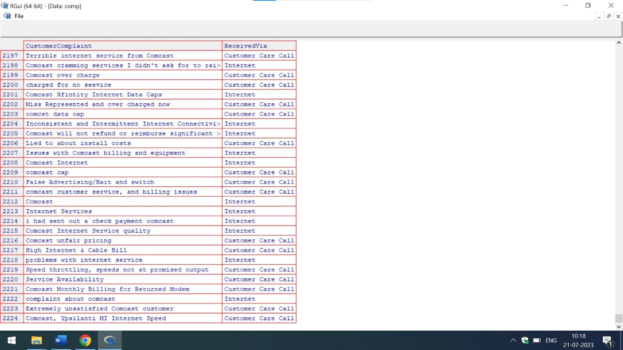

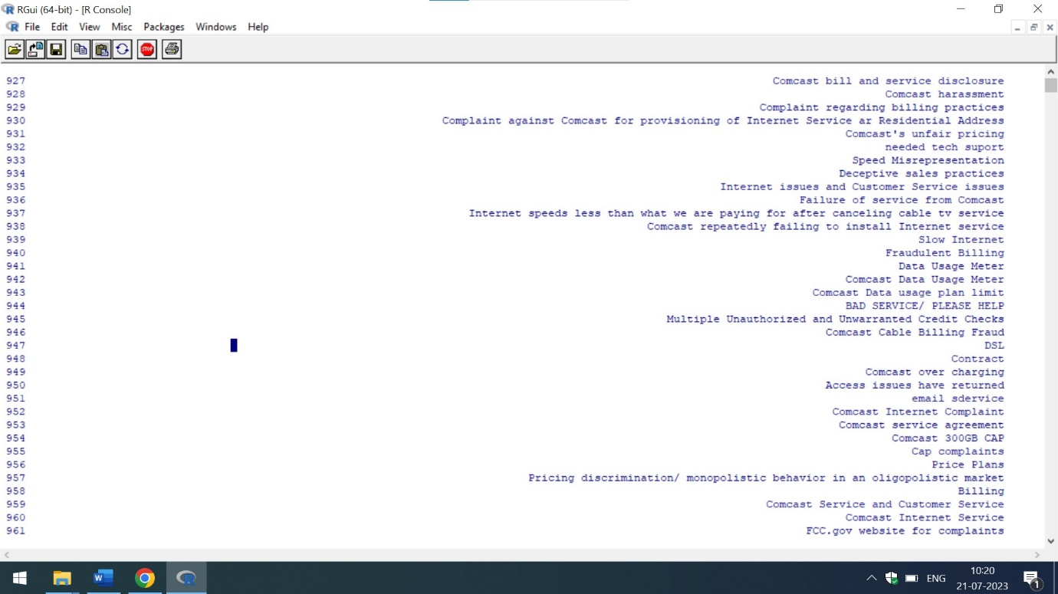

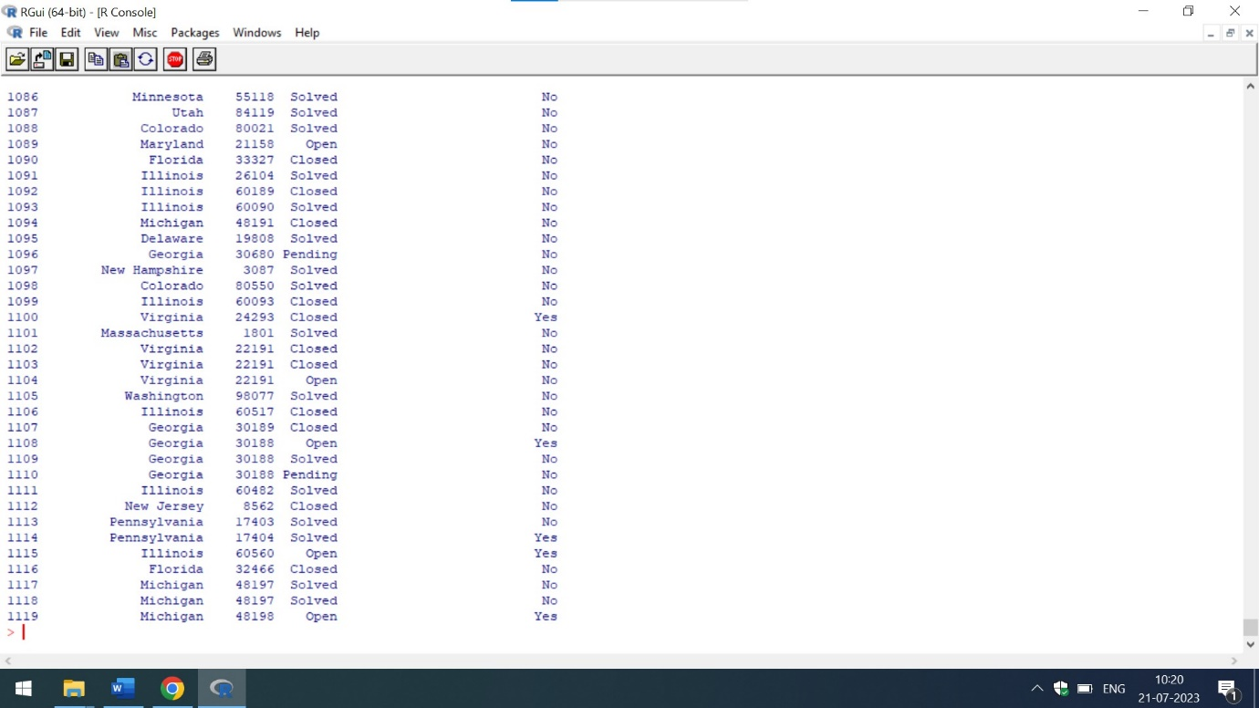

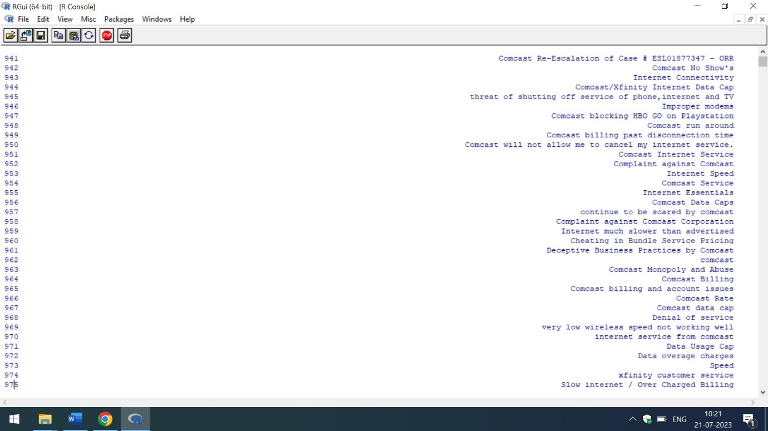

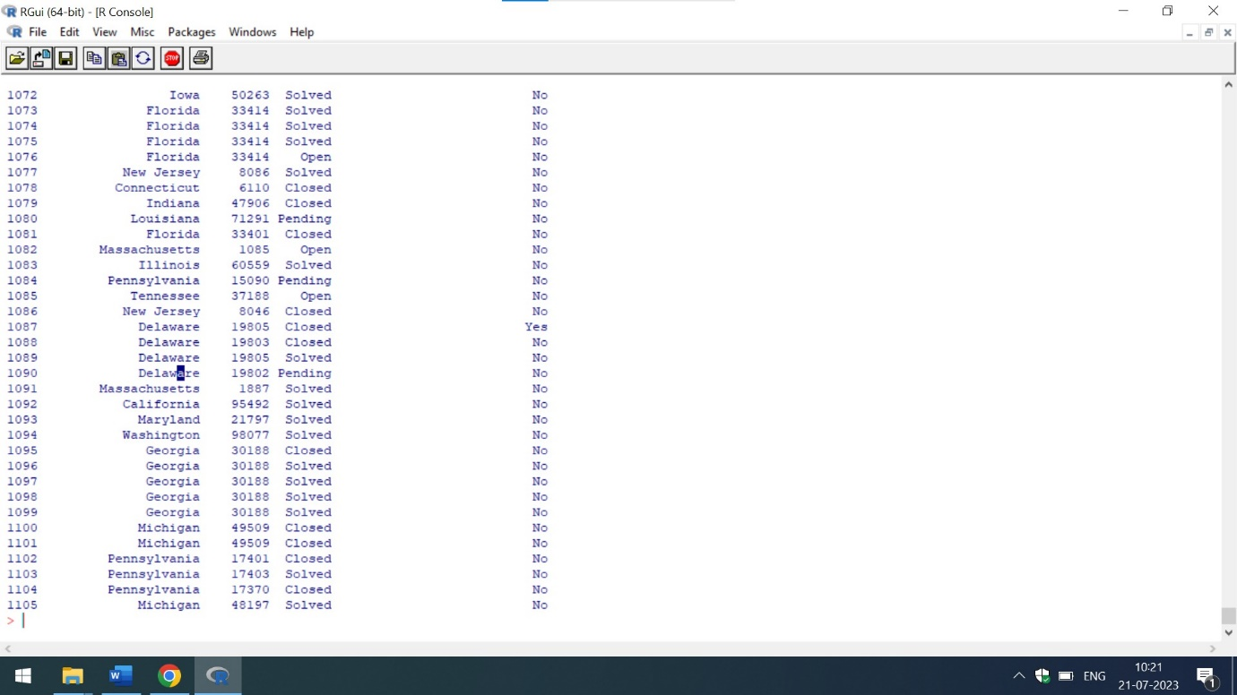

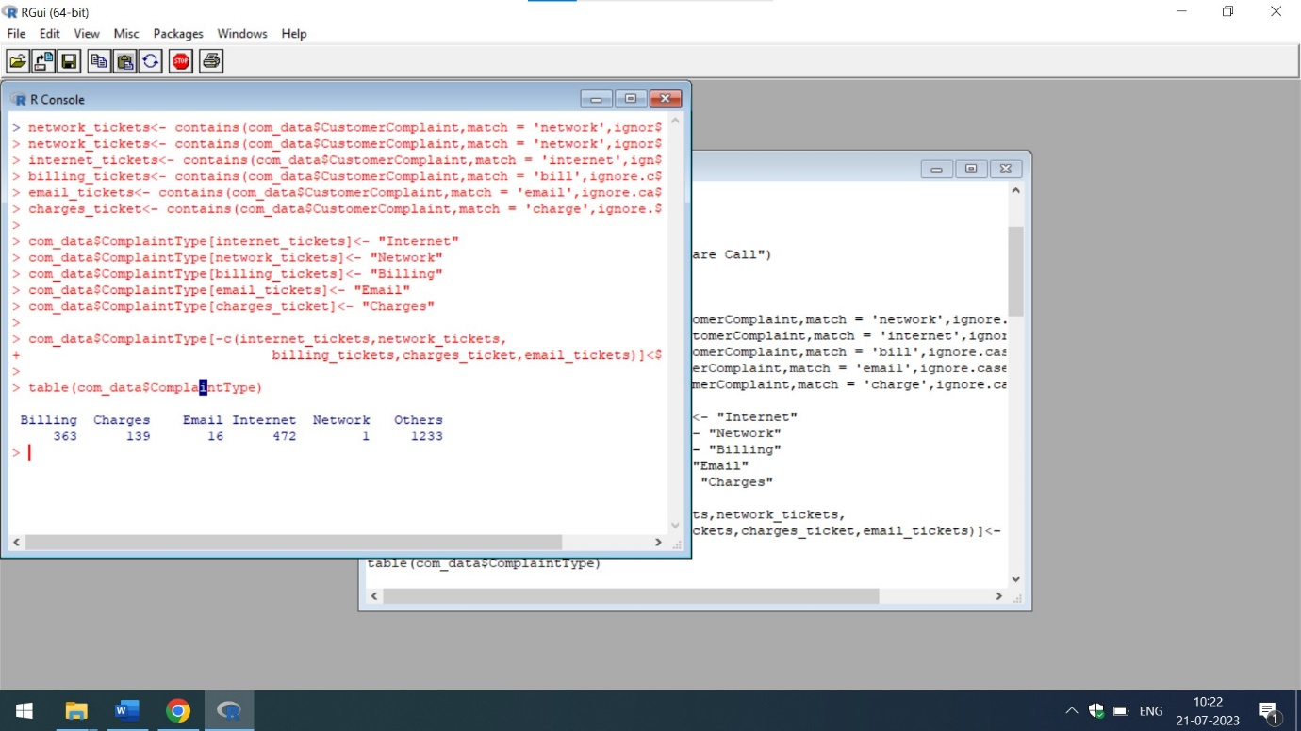

From the above mentioned screenshots,it is clear that most of the complaints are of Internet Category of Customer Complaint Section

Q4) Which complaint types are maximum i.e., around internet, network issues, or across any other domains.

Ans) The below attached is the code in R which represents the list of complaints Received via Customer Care Call and Internet

print("Comcast Telecom Consumer Complaints")

com_data<-read.csv("C:/Users/shiva/Desktop/Shivani/SimpliLearn/Data Science with R/Comcast.csv")

print(com_data)

comp<-com_data%>%select(2,5)

View(comp)

filter(com_data,ReceivedVia=="Customer Care Call")

filter(com_data,ReceivedVia=="Internet")

county<-table(com_data$CustomerComplaint,com_data$ReceivedVia)

barplot(county,col="blue")

newtrends <-ggplot(data=com_data,aes(x=ReceivedVia, y=CustomerComplaint,fill=Status))+geom_bar(stat="identity")

newtrends

The below attached is the output of the Number of Complaints Received via Internet and Customer Care Calls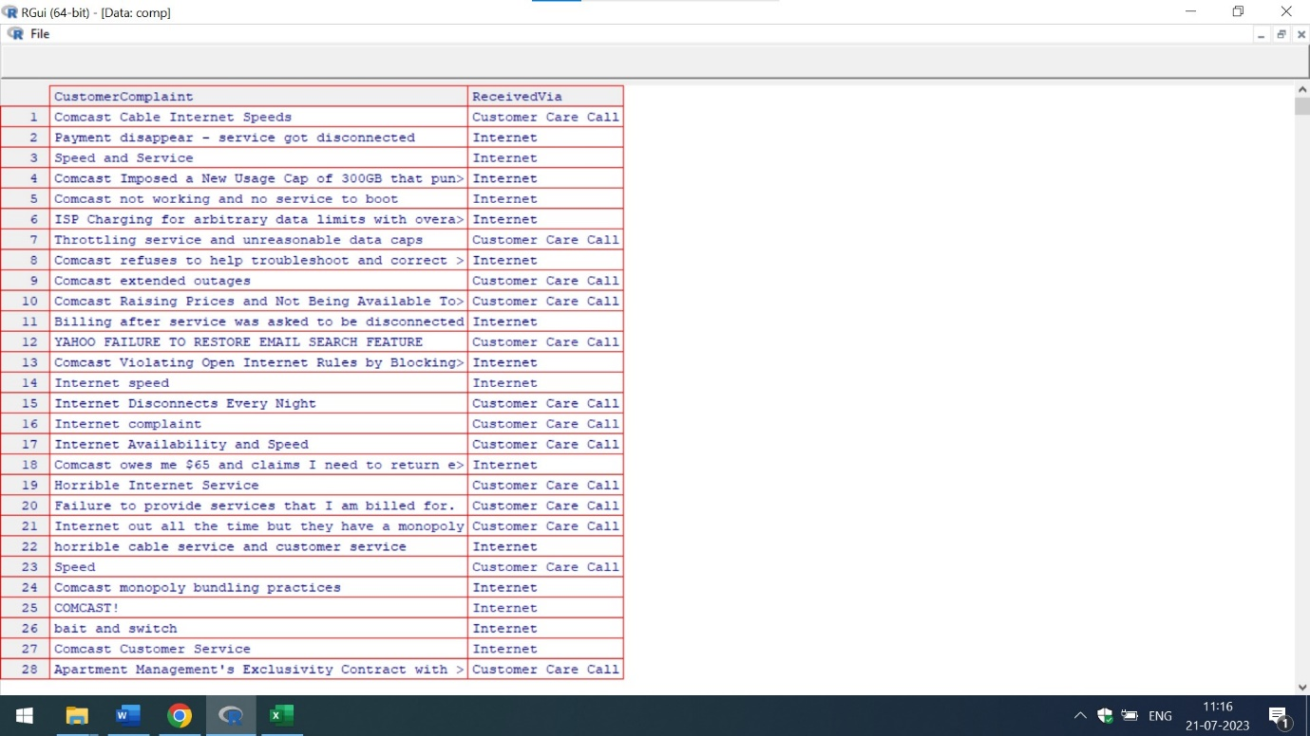

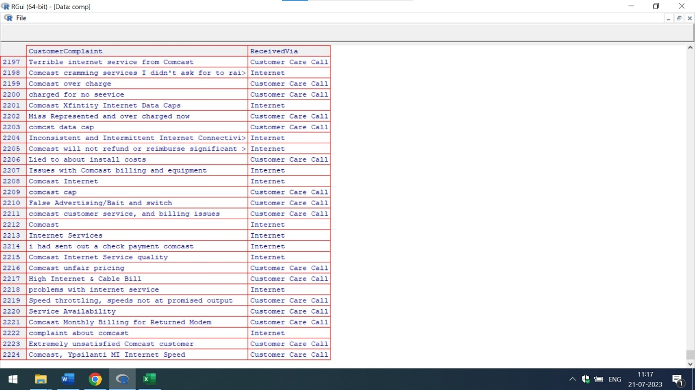

The number of complains Received via Customer Care Call are as follows:

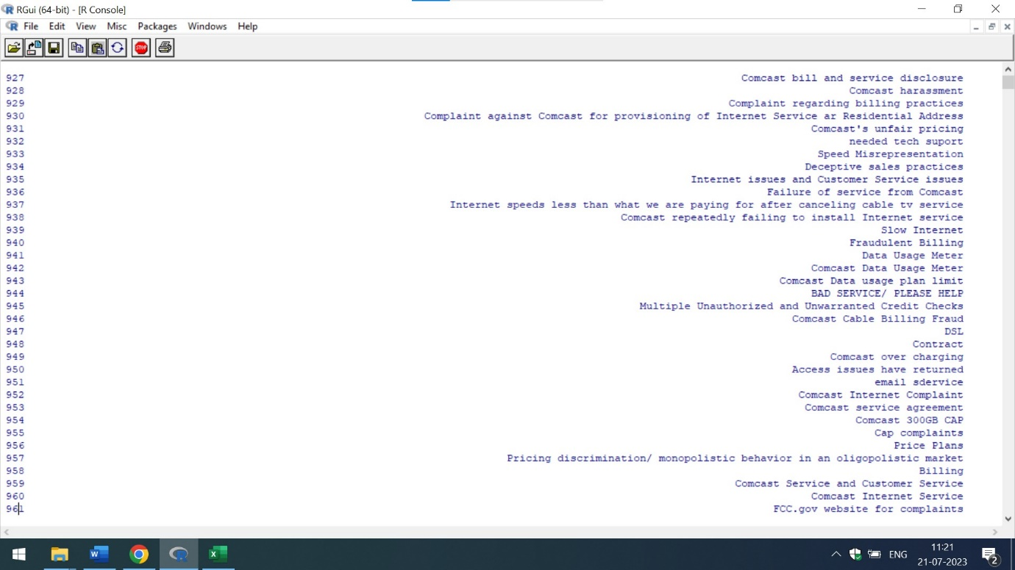

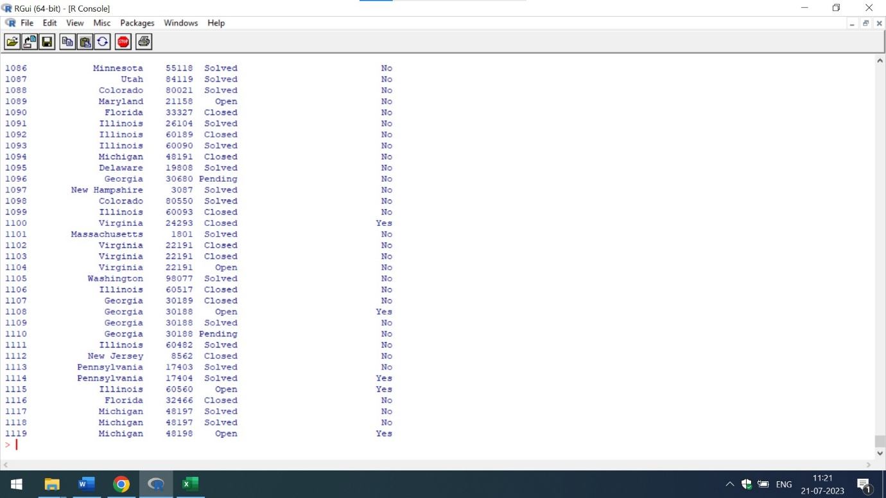

The number of Complains Received via Internet are as follows:

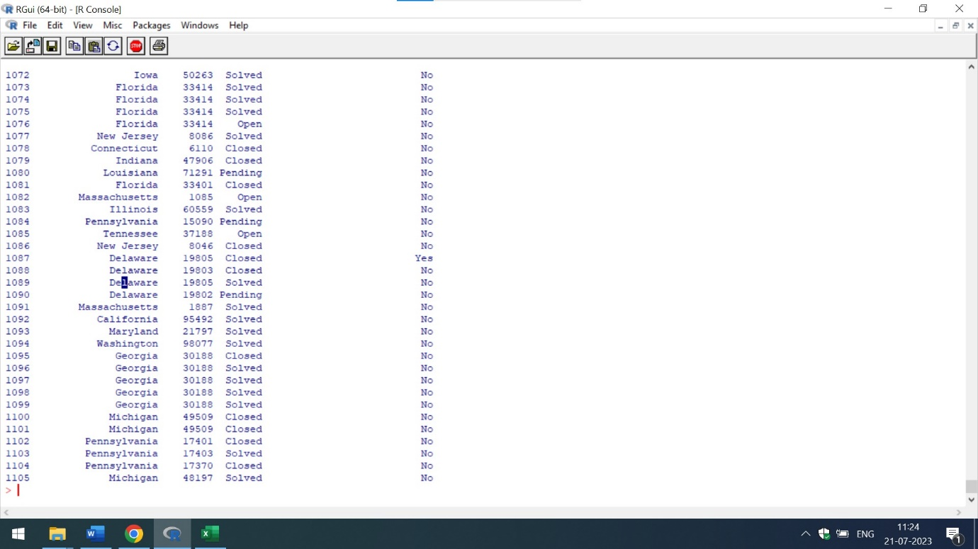

The number of Complains Received via Customer Care Call are 1119 while the number of complains Received via Internet are 1105. Hence, one can conclude that number of complaints Received via Customer Care Call are maximum.



The above mentioned Screenshot represents that the Internet Complains of the Customer Complaint Section are the maximum. Therefore, **Internet Complains Received via Customer Care calls are maximum in number**

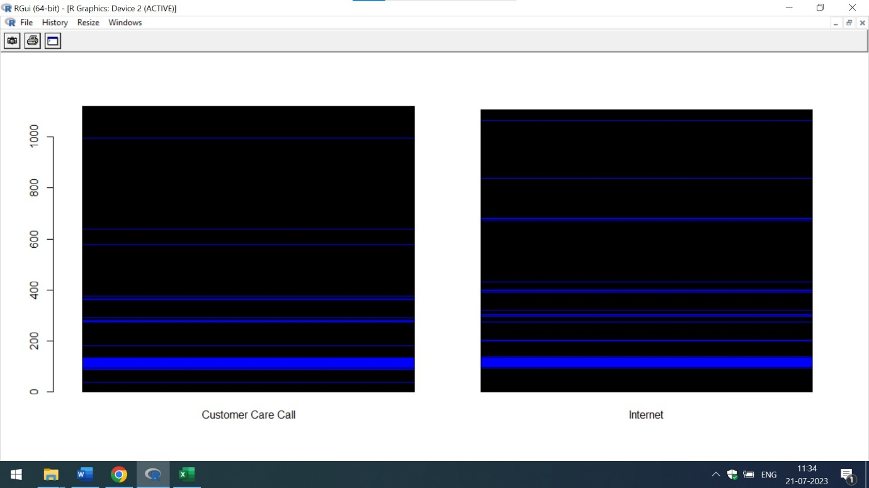

The above mention barplot also represents that Complains Received via Customer Care Call are slightly more than the Internet

It is also clear from the ggplot view that most of the complains are received via Customer Call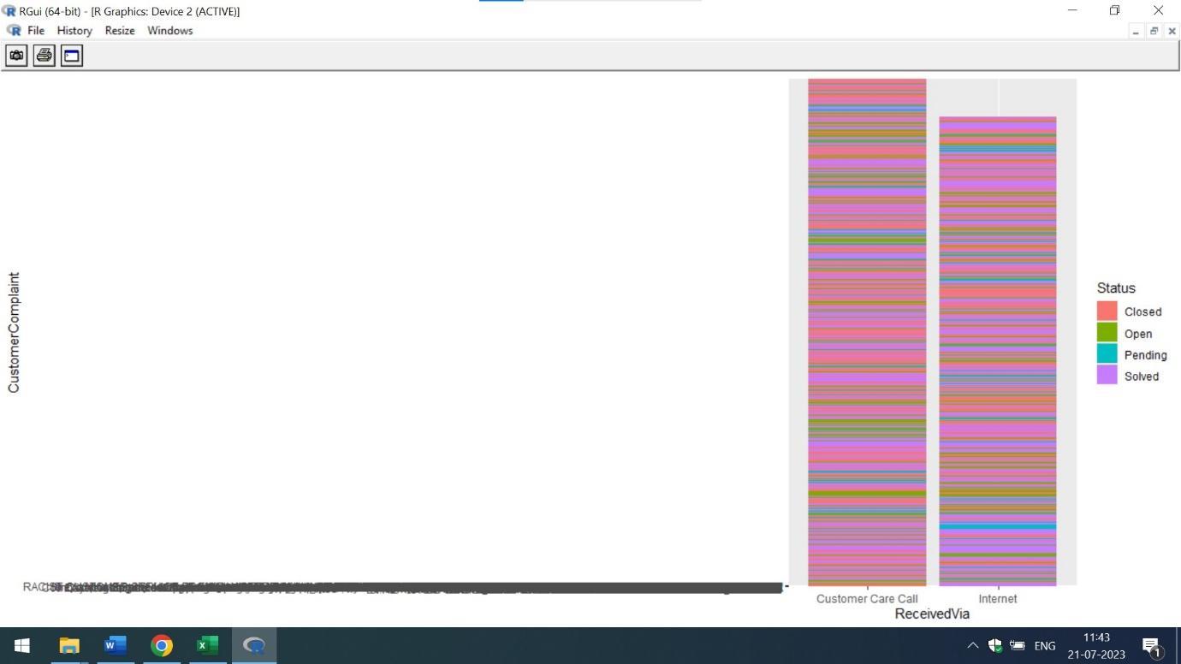

Q5) Create a new categorical variable with value as Open and Closed. Open & Pending is to be categorized as Open and Closed & Solved is to be categorized as Closed.

Ans) The new categorical variables of open complaints and closed complaints has been created. The customercomplains table give a brief idea of various customer complaints of several tickets. The below attached is the code in R

print("Comcast Telecom Consumer Complaints")

com_data<-read.csv("C:/Users/shiva/Desktop/Shivani/SimpliLearn/Data Science with R/Comcast.csv")

print(com_data)

View(com_data)

com_data%>%select(9)

open_complaints<- (com_data$Status == "Open"|com_data$Status =="Pending")

closed_complaints<-(com_data$Status == "Closed"| com_data$Status =="Solved")

customer_complains<-transform(com_data,customerstatus=ifelse(Status=="Open","Open",ifelse(Status=="Pending","Closed",ifelse(Status=="Solved","Closed","Closedbutnotsolved"))))

print(customer_complains)

View(customer_complains)

The below mention screenshot represents the tabular format of the customer complains and status allocation of Comcast Data

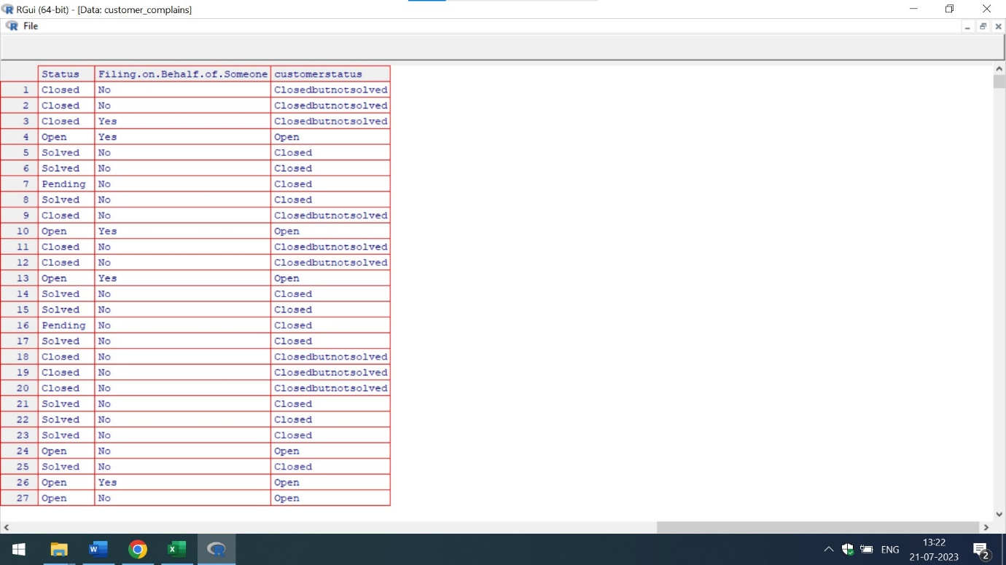

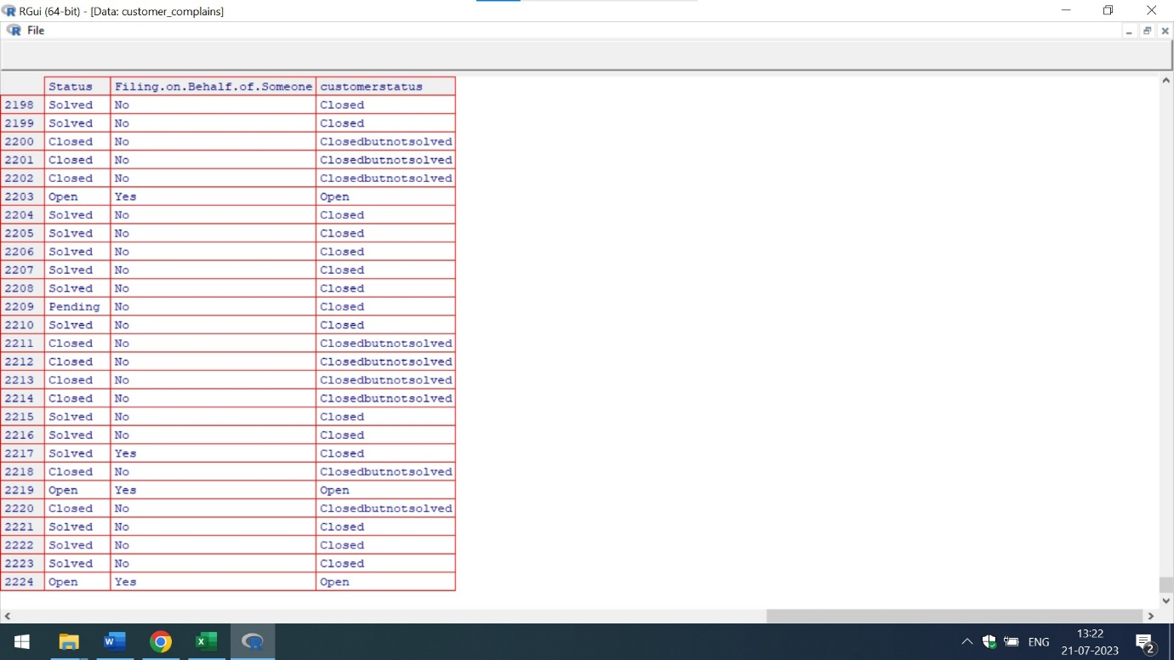

In the above mention screenshot,there is a separate column of customerstatus which shows that

Open Cases-> are described as Open

Pending Cases->are described as Closed

Solved Cases->are described as Closed

Q6) Provide state wise status of complaints in a stacked bar chart. Use the categorized variable from Q3. Provide insights on:

Which state has the maximum complaints

Which state has the highest percentage of unresolved complaints

Ans) The state wise view of complaints in a stacked bar chart is mention below:

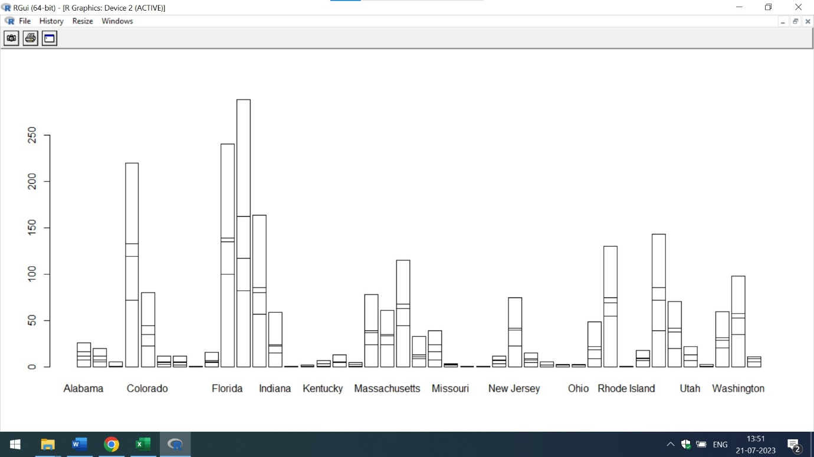

From the above mention graph,it is clear that Florida is the state with highest number of complaints

However,if I use filter then Georgia is the state which has the maximum customer complains

The below mention is the code in R for the state wise complains

print("Comcast Telecom Consumer Complaints")

com_data<-read.csv("C:/Users/shiva/Desktop/Shivani/SimpliLearn/Data Science with R/Comcast.csv")

print(com_data)

View(com_data)

t<-com_data%>%select(2,7,9)

View(t)

filter(t,State=="Alabama") # 26 complains

filter(t,State=="Arizona") # 20

filter(t,State=="Arkansas") #6

filter(t,State=="California") # 220

filter(t,State=="Colorado") #80

filter(t,State=="Connecticut") #12

filter(t,State=="Delaware") #12

filter(t,State=="District Of Columbia")#16

filter(t,State=="Florida") #240

filter(t,State=="Georgia") #288

filter(t,State=="Indiana")# 59 complains

filter(t,State=="Kentucky") # 7

filter(t,State=="Massachusetts") # 61 complains

filter(t,State=="Missouri") #4

filter(t,State=="New Jersey") #75

filter(t,State=="Ohio") #3

filter(t,State=="South Carolina") #18

filter(t,State=="Vermont") # 3

counts<-table(com_data$Status,com_data$State)

barplot(counts)

perf <-ggplot(data=com_data, aes(x=State, y=Status,fill=Status))+geom_bar(stat="identity")

perf

The below attached is the screenshots for the Number of Complains of Florida and Georgia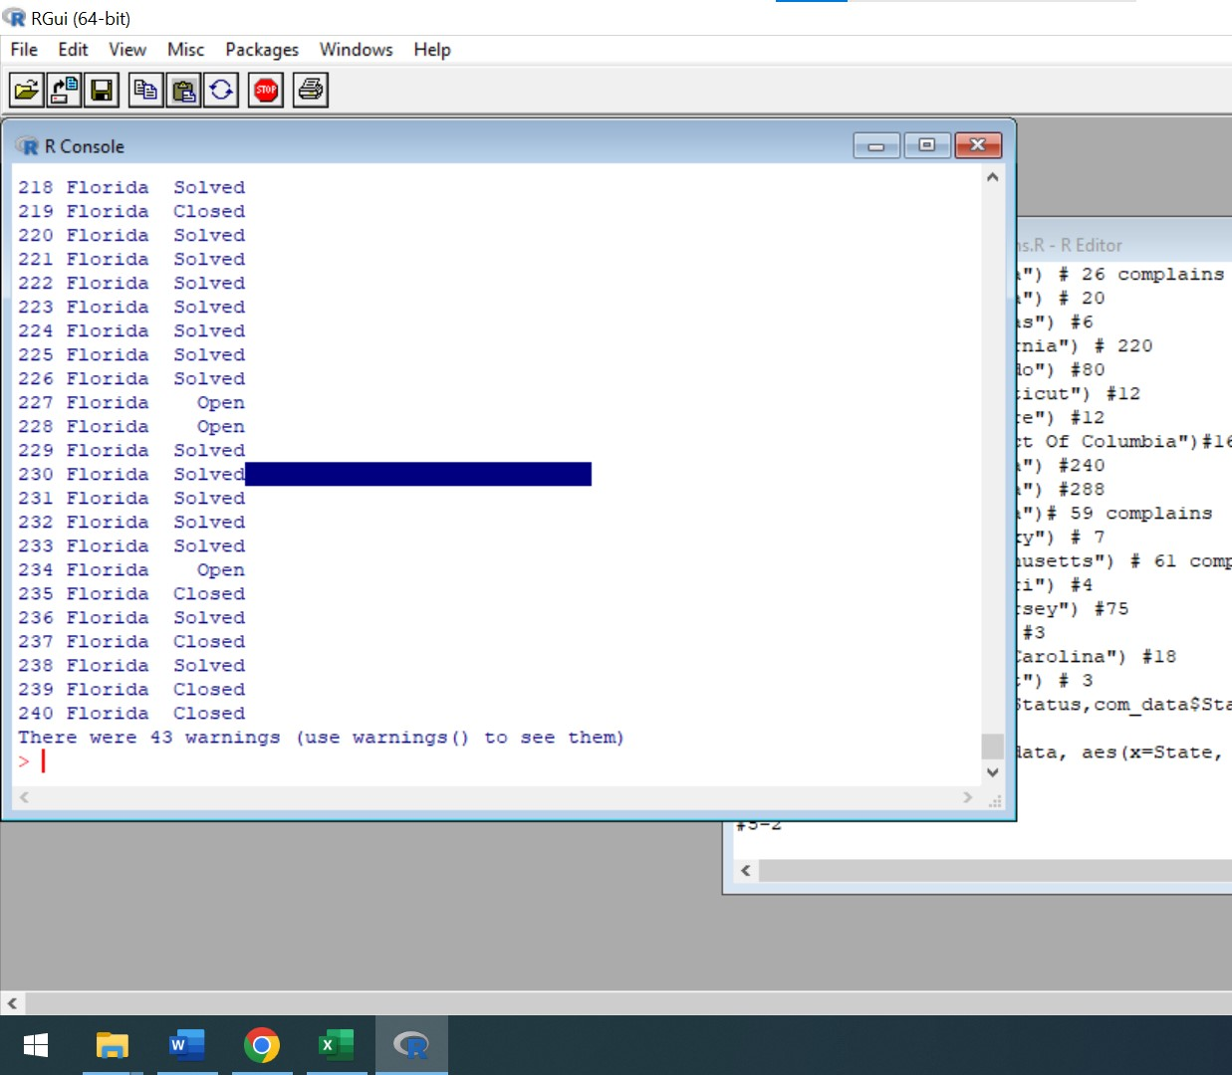

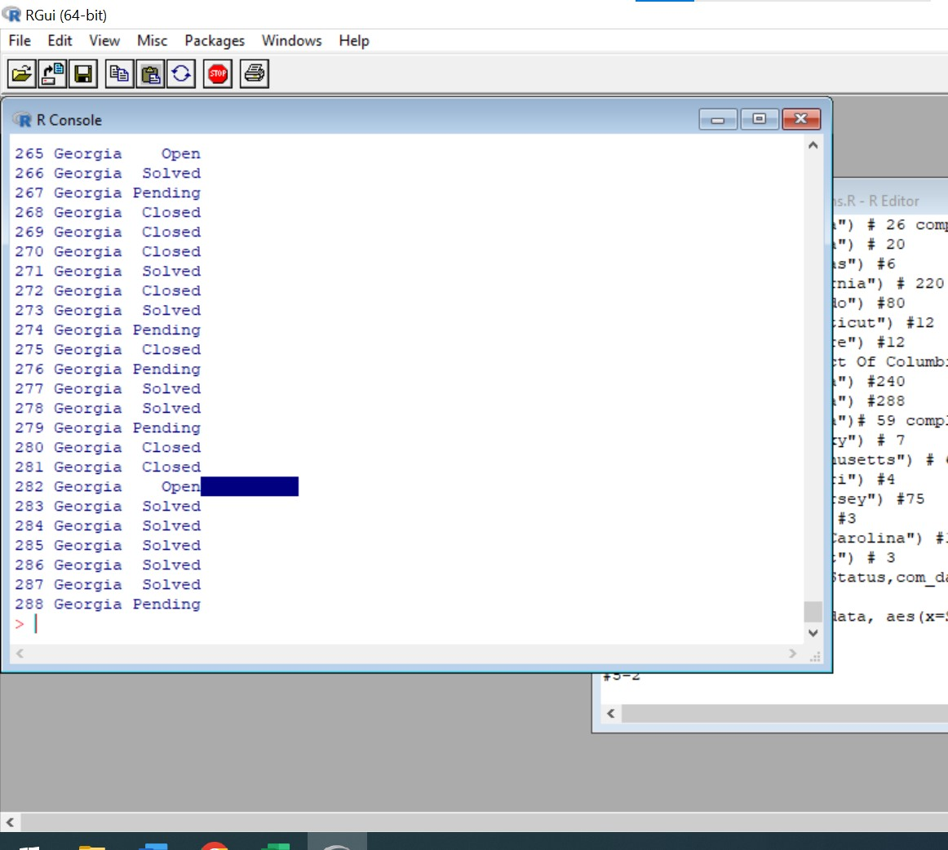

Hence,one can conclude that Florida and Georgia are the two states with Maximum complains.Georgia has the maximum complains ie 288 and Florida has 240

The state which has the highest number of Unresolved complains is Georgia

The below attached is the code of Percentage of Unresolve cases in Georgia

print("Comcast Telecom Consumer Complaints")

com_data<-read.csv("C:/Users/shiva/Desktop/Shivani/SimpliLearn/Data Science with R/Comcast.csv")

print(com_data)

s<-com_data%>%select(7,9)

View(s)

thestate<-filter(s,Status=="Open"|Status=="Pending")

View(thestate)

thecases<-filter(thestate,State=="Georgia")

View(thecases)

totals<-filter(t,State=="Georgia") #288

print(totals)

# Percentage Analysis

a=80

b=288

c=a/b

print(c)

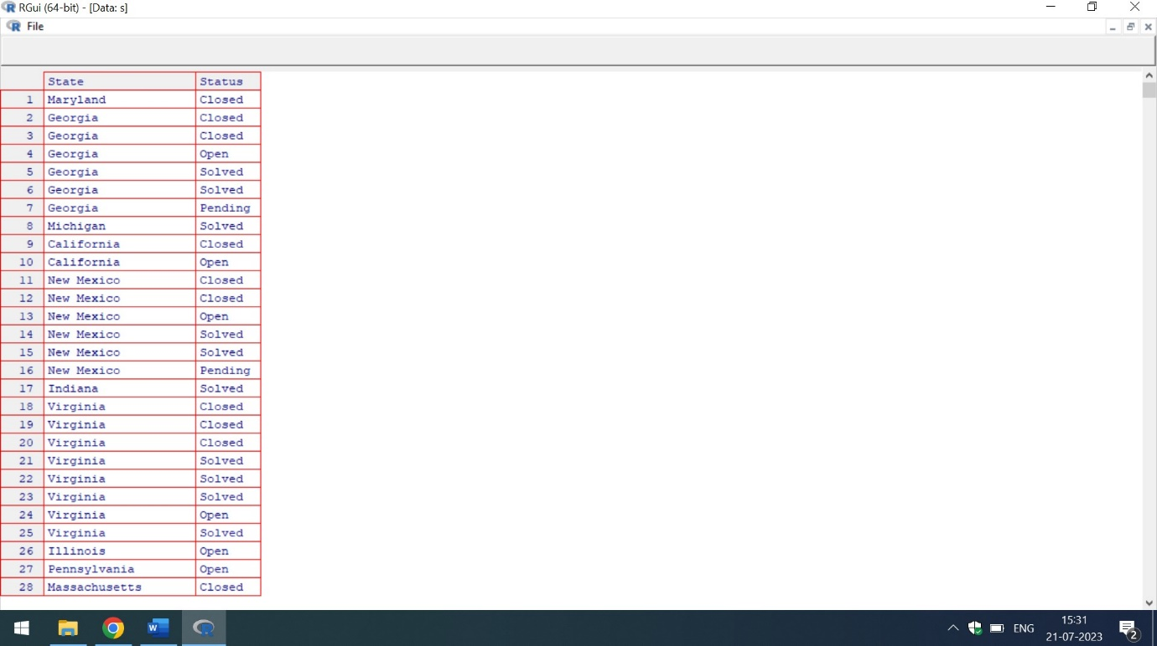

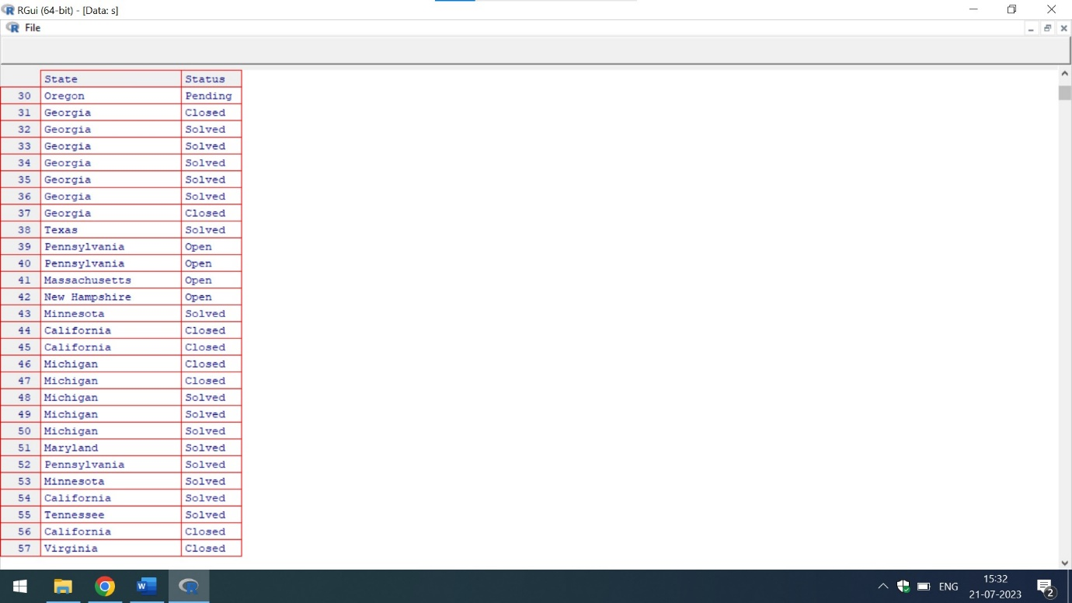

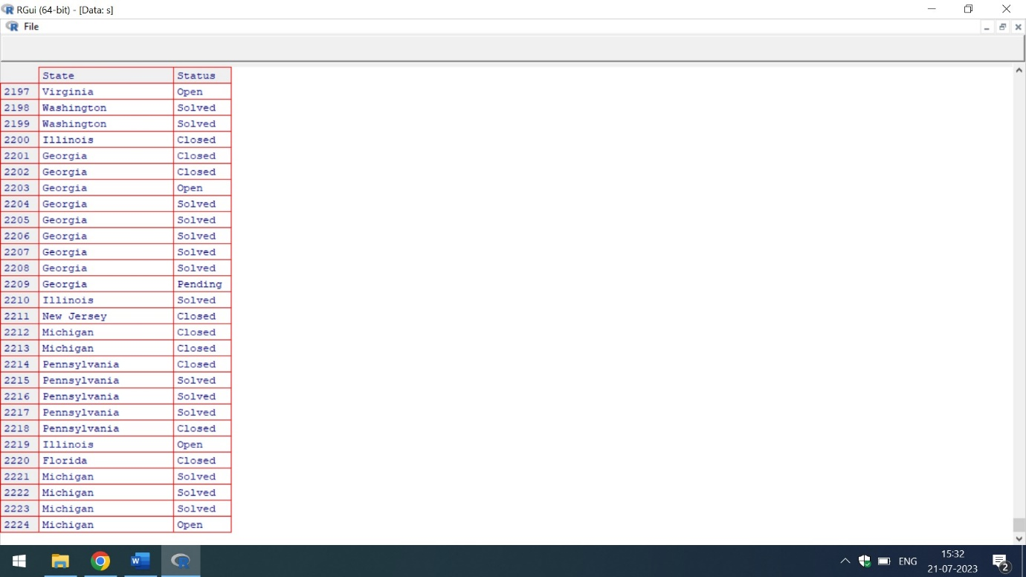

From the above mentioned screenshots,it is clear that Georgia has highest number of cases.

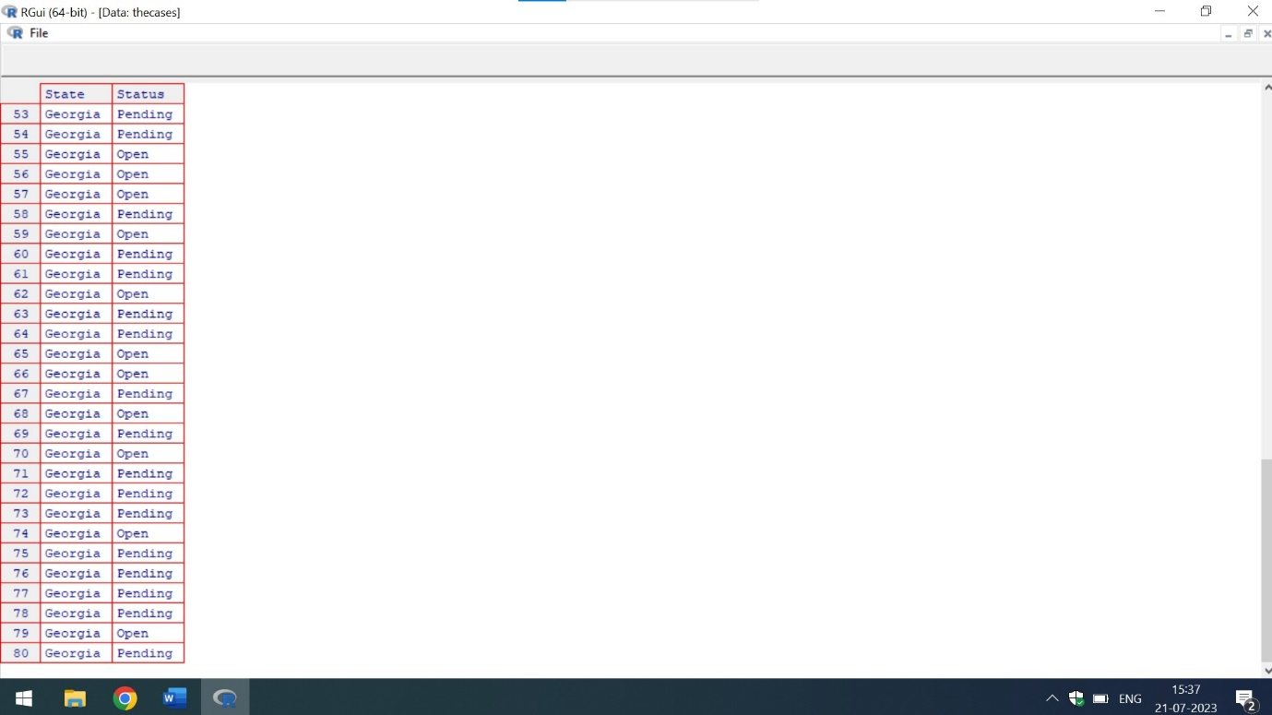

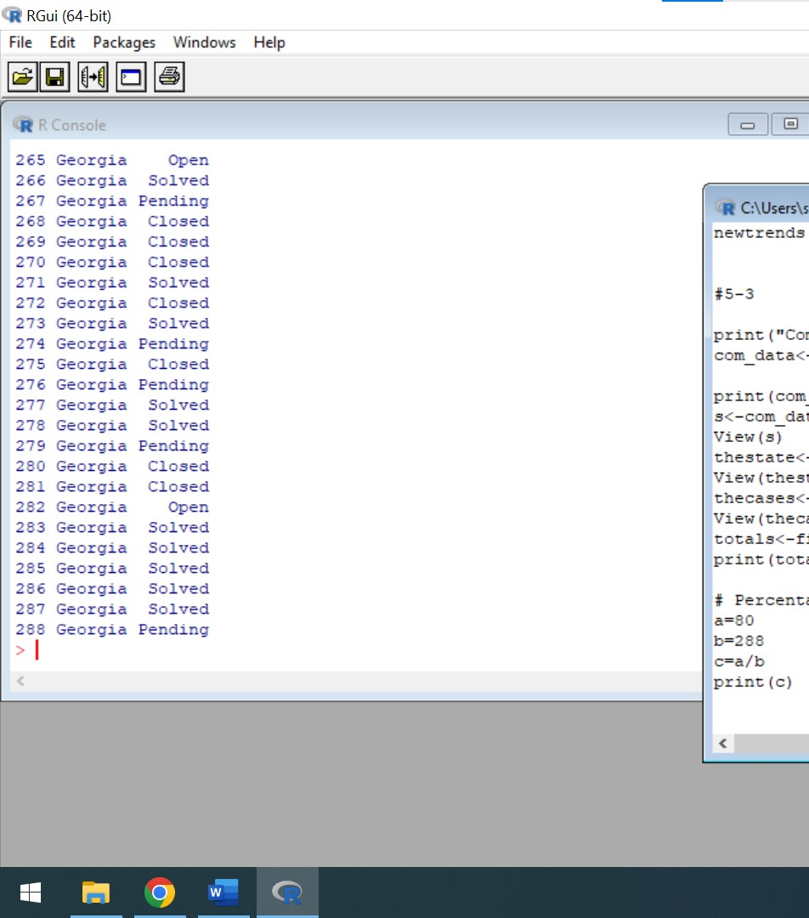

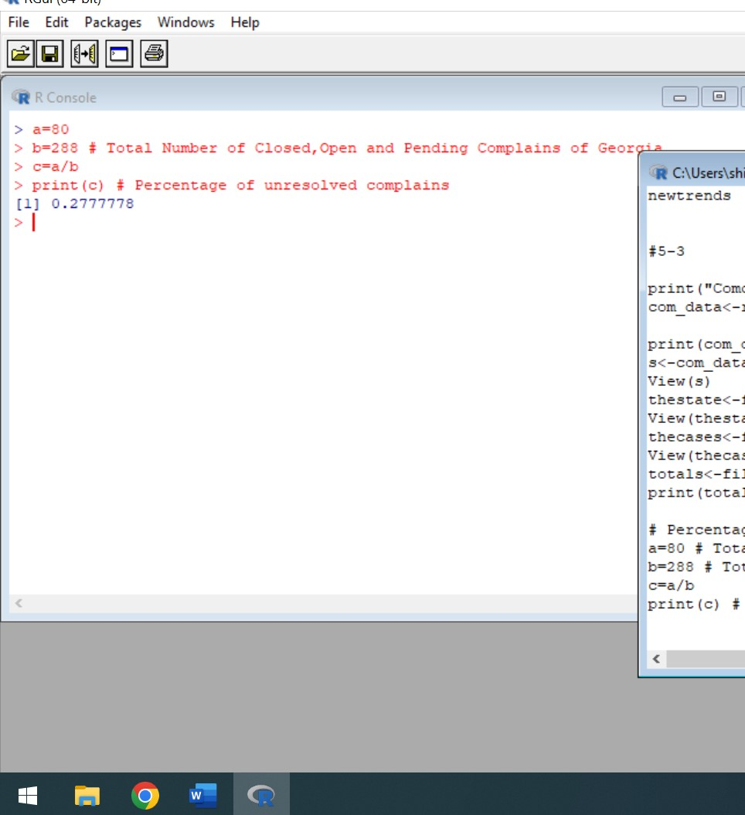

The state Georgia has total 80 cases which are in open or in pending

However, Total Number of Cases(Solved+Closed+Pending) of Georgia is 288

Hence,Pecentage of unresolved complains of Georgia State is

a=80 # Total Number of Open and Pending Complains of Georgia

b=288 # Total Number of Closed,Open and Pending Complains of Georgia

c=a/b

print(c) # Percentage of unresolved complains

Hence,The Percentage of unresolved complains is around 28%

Q7) Provide the percentage of complaints resolved till date, which were received through theInternet and customer care calls.

Ans) For analysis of complains resolved till date, I am considering only the solved entry of Status Column

The below attached is the code in R which shows total percentage of complaints resolved till date through the Internet and customer care calls.

print("Comcast Telecom Consumer Complaints")

com_data<-read.csv("C:/Users/shiva/Desktop/Shivani/SimpliLearn/Data Science with R/Comcast.csv")

print(com_data)

View(com_data)

filter(com_data,ReceivedVia=="Customer Care Call")#1119

filter(com_data,ReceivedVia=="Internet") #1105

filter(com_data,ReceivedVia=="Customer Care Call" & Status=="Solved") #477

filter(com_data,ReceivedVia=="Internet" & Status=="Solved") #496

customercare=477/1119

print(customercare)

internet=496/1105

print(internet)

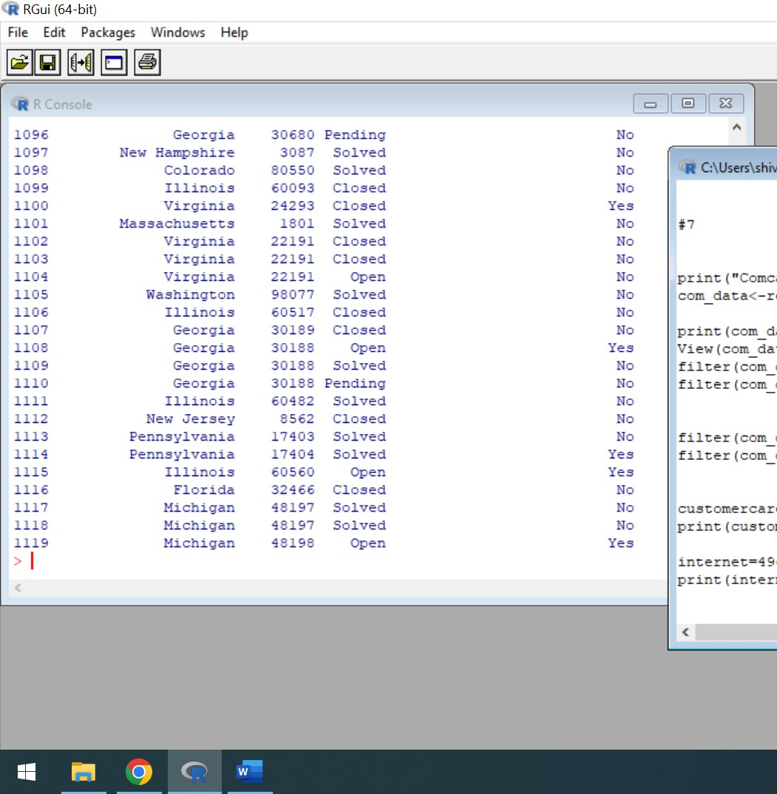

The above mentioned screenshot represents the total Data Received by Customer Care Call which has both open,solved,closed and pending cases. The count is 1119

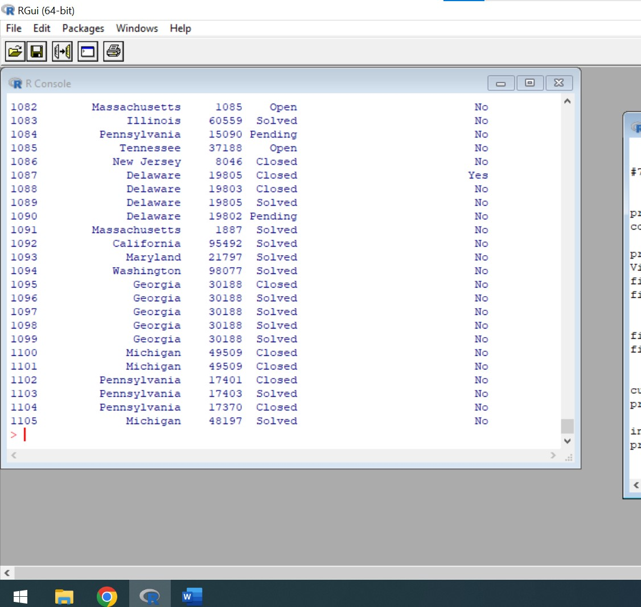

The above mentioned screenshot represents the total Data Received by Internet which has both open,solved,closed and pending cases. The count is 1105

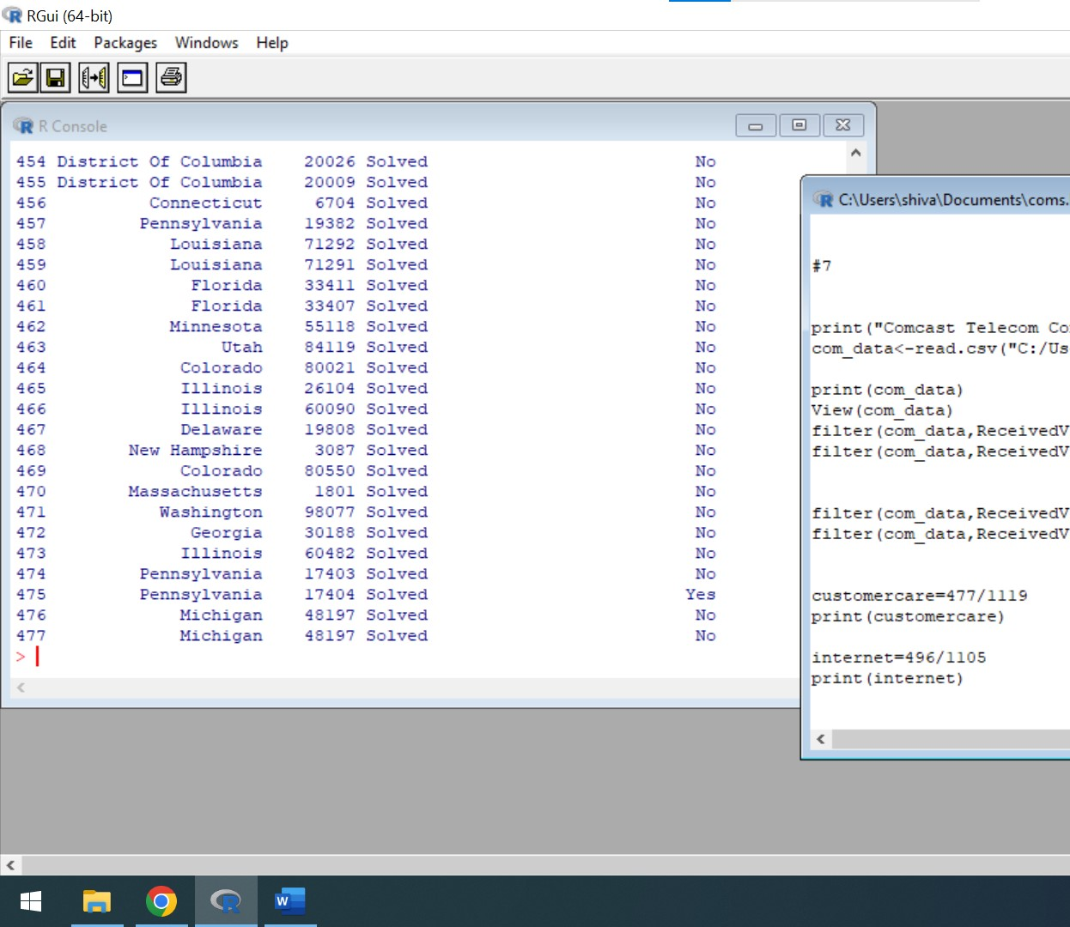

The total number of solved cases via Customer Care call is 477

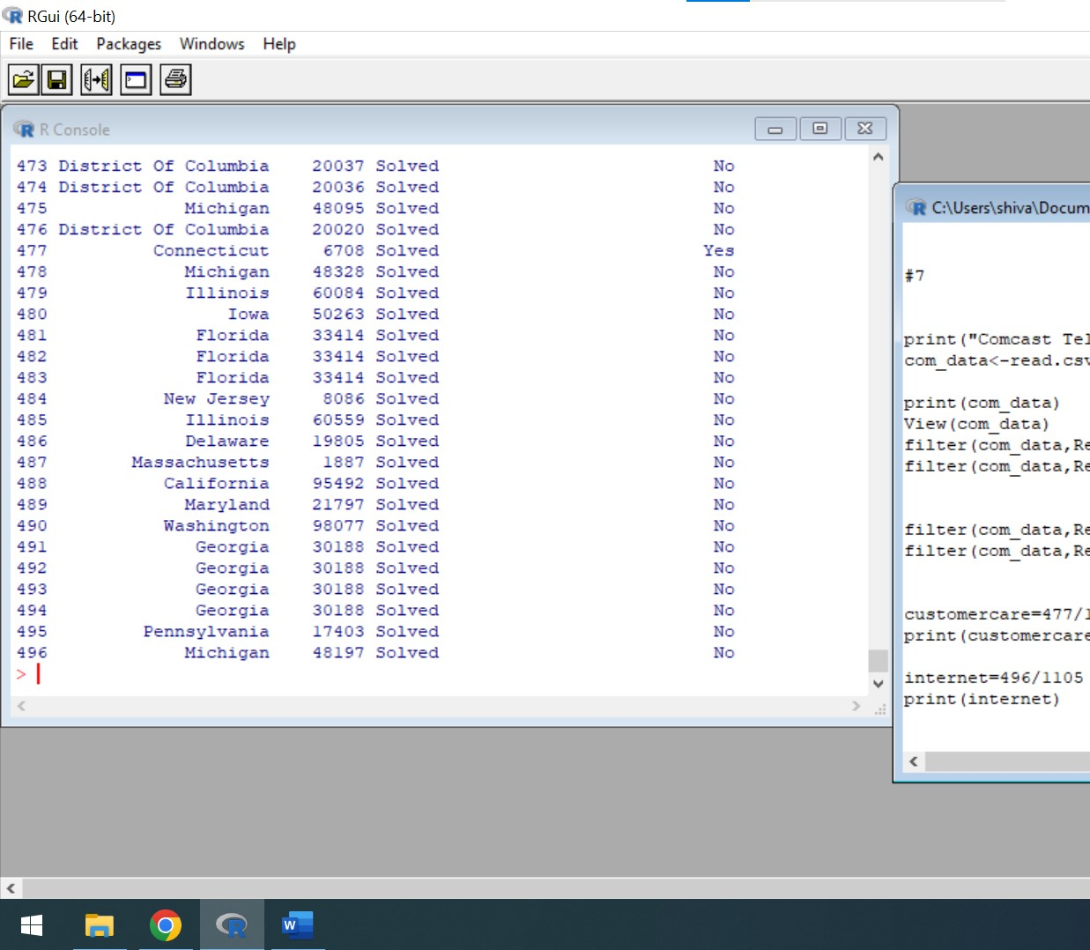

The total number of solved cases via Internet is 496

The number of solved cases of customer care calls is 42.6 %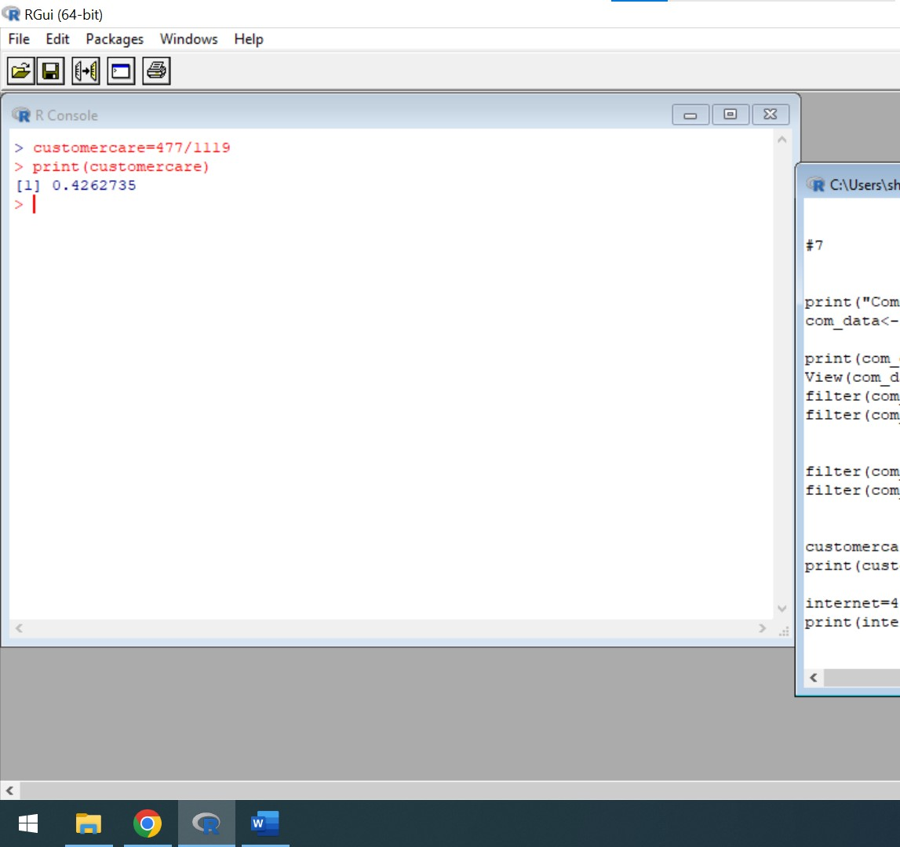

The number of solved cases via Internet is 44.8%